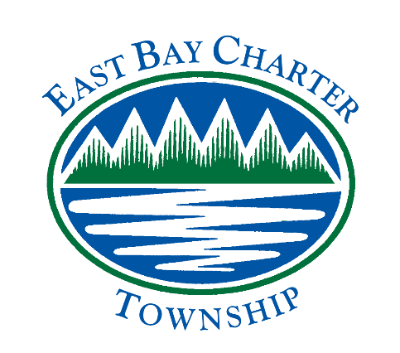
Notice Posting: March 15, 2018

REGULAR MEETING OF THE
EAST BAY CHARTER TOWNSHIP PARK COMMISSION
East Bay Township Hall at 1965 N. Three Mile Road
~ March 19, 2018 ~ 6:00 P.M.

- Call Meeting to Order
- Pledge of Allegiance
- Roll Call
- Public Comment
- Approval of the Agenda
- Approval of the minutes of the January meeting
- Reports
A. Treasurer Report
B. Rec Plan
C. Subcommittee for Grants
- Old Business
- New Business
- Public Comment
- Adjournment

If you are planning to attend this public meeting and are disabled requiring any special assistance,
please notify the Township Clerk by calling at (231) 947-8647 as soon as possible.

